CH4203: Organic Synthesis Laboratory

Expt. No. 7: L-Proline Catalyzed Asymmetric Aldol Reaction of Acetone with p-Nitrobenzaldehyde

Home Assignment Due date: 7 days after the expt. done

(Q1) Write down the mechanism of Organocatalytic Aldol Reaction of acetone with p-nitrobenzaldehyde catalyzed by L-Proline.
[1+2+2 = 5]

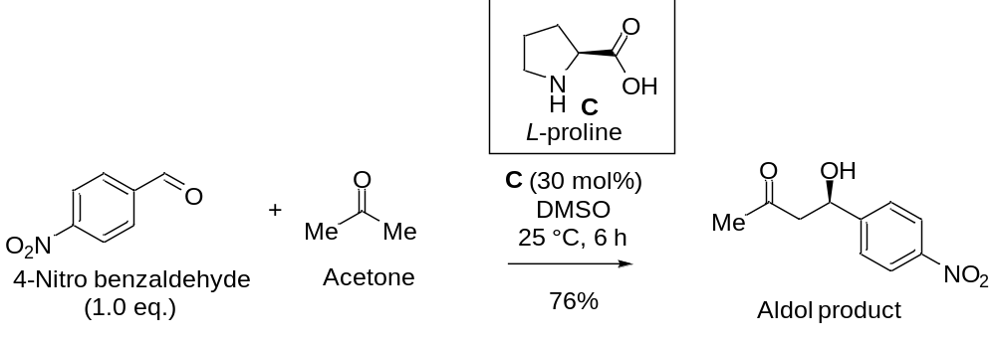

(Q2) Explain this by proposing a transition state clearly showing how enamine is helping in induction of enantioselectivity. What will happen if we react the Aldol product with NaBH₄? Show mechanism of this reduction in MeOH. [1+2+2 = 5]

